Siddharth Patel - U23306593 – 2/28/25
SDM A2 Hunters Green Home Sales

- Create a table of relevant predictors, hypothesized direction of effect (+/-), and rationale for each hypothesized effect. (2 points)

Predictor | Effect | Rationale
DV: pricesold
sqft | + | Larger homes will sell for more price
beds | + | More bedrooms increase home value
listprice | - | Higher list price will attract less bidding and hence final sale price may be low
Lpperspft | - | Higher list price per sqft will attract less bidding and hence final sale price may be low
pendingdate | + | House prices tend to change year over year, we must extract the year portion of pending date and factorize it as a predictor
Bathstotal | + | Houses with more bathrooms will sell for more price
bathsfull | + | Houses with more bathrooms will sell for more price
Bahtshalf | + | Houses with half bathrooms will sell for more price
Garages | + | Houses with more garages will sell for more price
Roof | + | Tile roof houses will be more expensive than shingle roof houses. Combining into two primary categories Tile and Shingle roof.
Lotsqft | + | House with larger lots will sell for more price as buying more land
Yrblt | + | House values decrease as they get older. Newer houses sell for more price.
Pool | + | Houses with private pools will have more value. Houses with community access pools will have less value than a private pool house. Houses with no pools will have the least value.
splsale | - | Auction, Bank owned, short sale houses have lower selling price than what it would normally sell for.
Excluded: slonskm, Stat, Address, Subdivision, Adom, Cdom, datesold
DV: adom
lppersqft | + | Homes listed with high list price per sq ft will sell slower (stay in market longer)
Listprice | + | Higher list price will attract less bidding and hence will stay on market longer
Beds | +/- | Houses with more bedrooms will sell faster, but adding more and more bedrooms will increase price and eventually more expensive houses will sell slower. Ideally 3-4 bedrooms houses sell fastest.
Bathstotal | +/- | Houses with more bathrooms will sell faster, but adding more and more bathrooms will increase price and eventually more expensive houses will sell slower. Ideally 2-3 bathrooms houses sell fastest.
Yrblt | + | Older houses will sell slower
Splsale | + | Splsale houses have a lower list price and will sell the fastest
Other variables appear to be unrelated with the number of listing days

Descriptive analysis (not asked for but is a requirement for model building)

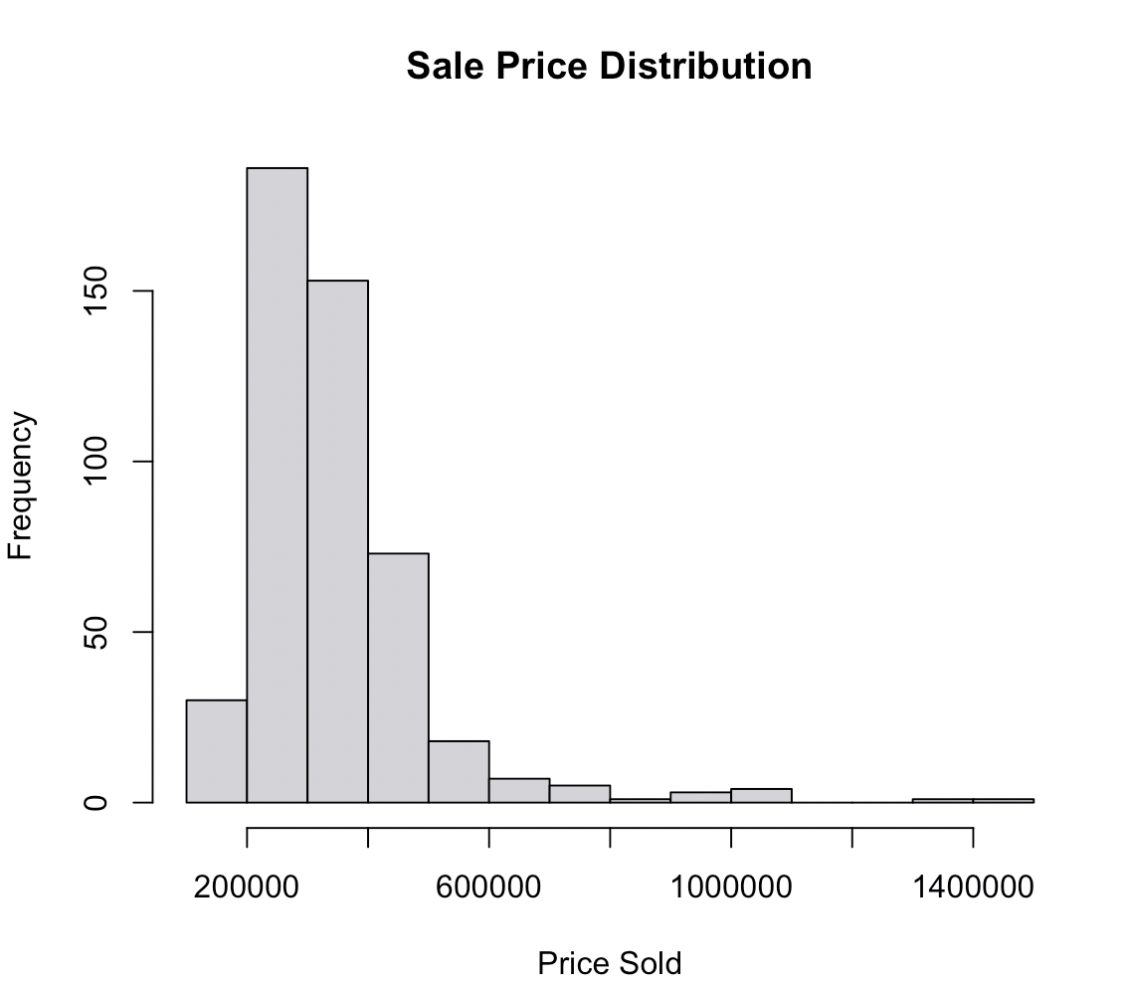 | 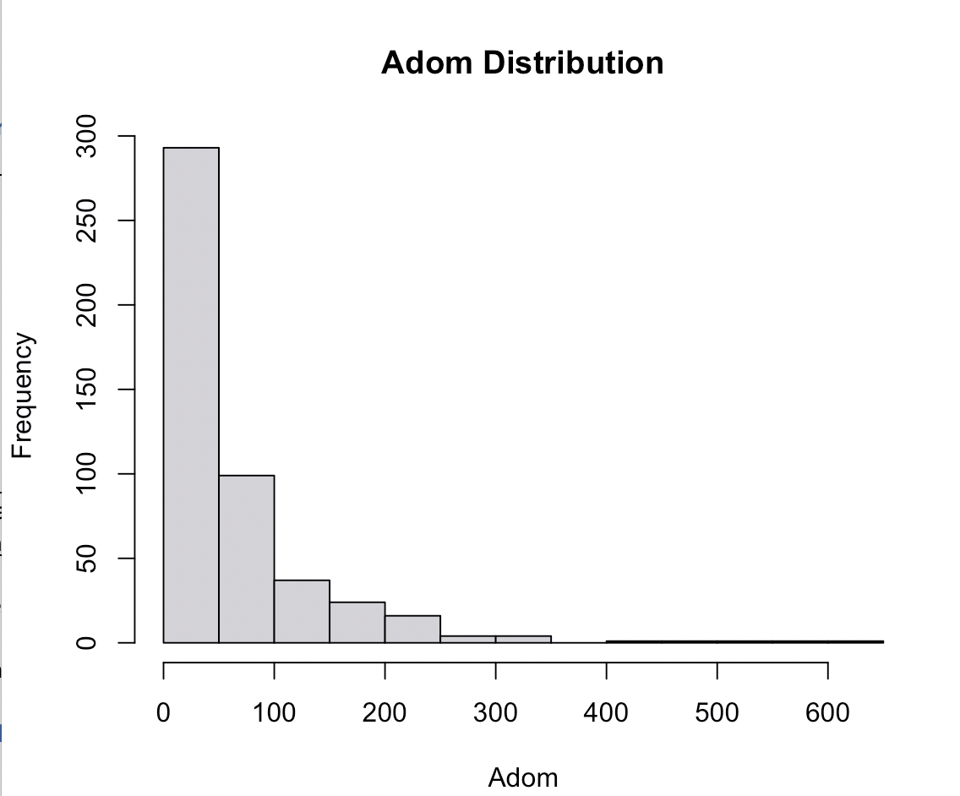 | 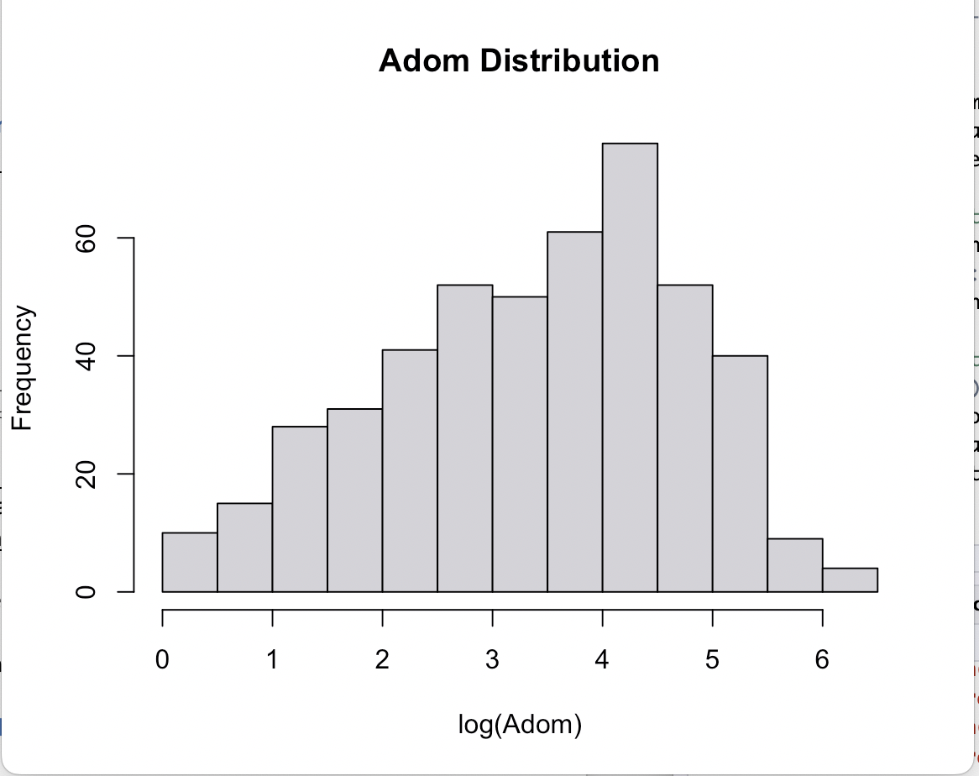
OLS may work for pricesold | log(adom) plot shows that an exponential model will be better, but not using for this assignment

High correlation (>0.8) between listprice, sqft, and lotsqft; between pricesold and listprice (1.00); and between baths, pricesold, listprice, and sqft. Since sqft is a core predictor of pricesold, we must drop listprice and lotsqft from our analysis. We keep baths though it has a 0.85 correlation with sqft.

- Run a set of three reasonable models for each DV. Copy and paste the R code for the three models and the combined output using stargazer. (3 points)

Models for sales price:
price1 = lm(pricesold ~ year, data=data)

price2 = lm(pricesold ~ Beds + baths + garages + roof_tile + privatepool + communitypool, data=data)

price3 = lm(pricesold ~ sqft + year + yrblt, data= data)

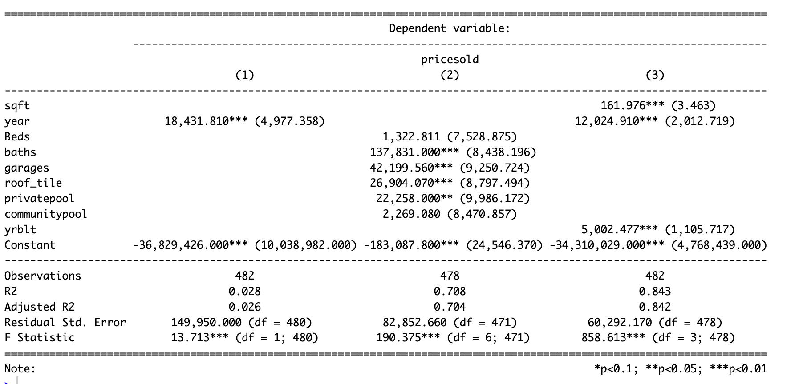
Models for days on market:
adom1 = lm(adom_agentdaysonmarket ~ year, data=data)

adom2 = lm(adom_agentdaysonmarket ~ listprice+yrblt, data=data)

adom3 = lm(adom_agentdaysonmarket ~ listprice+yrblt+splsale+Beds+baths, data= data)

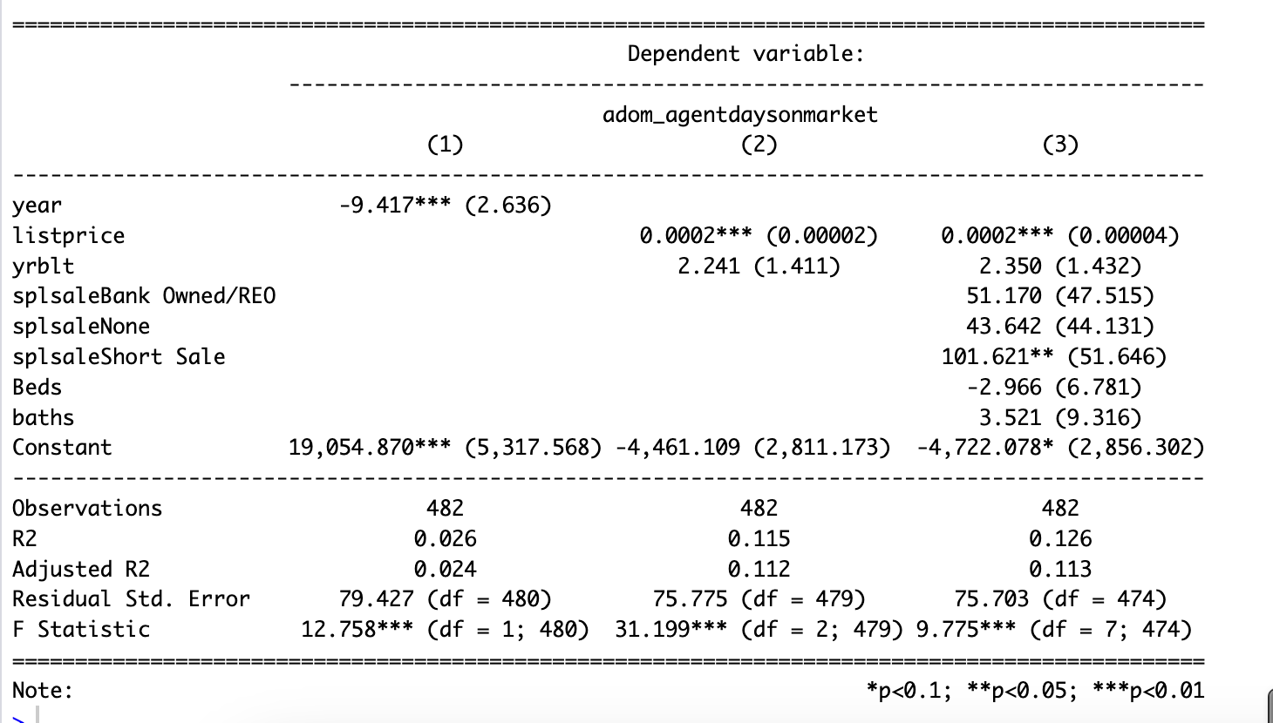

- Select the best model from each set and examine whether it meets the assumptions of the regression model. Which of the five regression assumptions are met for the final models? (2 points)
Assumption | Model: price3 | Model: adom3
Linearity | Residuals vs. fitted plot – some curvature- Failed | Residuals vs. fitted plot – some curvature- Failed
Normality | Shapiro-Wilk’s test: W = 0.92151, p-value = 3.726e-15 - Failed | Shapiro-Wilk’s test: W = 0.83883, p-value < 2.2e-16 - Failed
Homoskedasticity | Bartlett’s test: Failed  Bartlett's K-squared = 306.79, df = 1, p-value < 2.2e-16 | Bartlett’s test: Failed  Bartlett's K-squared = 393.45, df = 1, p-value < 2.2e-16
Multicollinearity | Passed - sqft year yrblt  1.079351 1.011439 1.077435 | vif(adom3): Passed
Independence | Durbin-Watson test: Passed  DW = 1.5596, p-value = 4.892e-07 | Durbin-Watson test: Passed  DW = 1.857, p-value = 0.0504

- Using your best models, select the top three predictors of adom and pricesold, and explain their marginal effects on the dependent variables. Remember that significance is not important. (2 points)
Top 3 predictors for pricesold (from model price3 to avoid extreme multicollinearity):
- Sqft – for 1 square feet increase, price will increase by 162$
- Year – for every 1 year increase in pending date year, sale price increases by 12,020$.
- Year built – For every 1 year newer built, house price will increase by 5002$
Top 3 predictors for adom (from model adom3): goal to have lowest adom
- Beds – For every 1 bedroom, adom deceases by 2.97 days.
- Listprice – For every 1$ increase in listprice, adom increases by 0.00015 days.
- Yrblt - For every 1 year newer built, adom increases by 2.35 days.

Appendix – R code

attach(data)
View(data)

summary(data)
str(data)

#combine bathsfull and bathshalf into 1 variable
baths=bathsfull + 0.5*bathshalf

#Create binary indicators
specialsale = ifelse(splsale == 'None',0,1)
roof_tile = ifelse(Roof == "Tile", 1, 0)
privatepool = ifelse(Pool %in% c("Private", "Private, Community"), 1, 0)
communitypool = ifelse(Pool %in% c("Community", "Private, Community"), 1, 0)

#Extracting year from pending data
PendingDate = as.Date(PendingDate, format="%Y-%m-%d")
year = as.numeric(format(PendingDate, "%Y"))

#check for missing values
which (!complete.cases ( data ) )
colSums(is.na (data) )

# Removing columns with excessive missing values
data = data [ , -c (1:3 , 5:7 , 10 , 13:15 , 17 , 20 , 22:24) ]

# Plotting hi st og ra ms for pricesold and adom
hist(pricesold, main="Sale Price Distribution", xlab="Price Sold")
hist(adom_agentdaysonmarket, main="Adom Distribution", xlab="Adom")
hist(log(adom_agentdaysonmarket), main="Adom Distribution", xlab="log(Adom)")

#coorelation plot for variables
library(PerformanceAnalytics)
temp = data[,c(1:10)]
chart.Correlation(temp)

#Correlation plot with IV
library(corrplot)
correlationall=cor(data)
View(correlationall)
corrplot(correlationall)

#Regression models for pricesold
price1 = lm(pricesold ~ year, data=data)
summary(price1)

price2 = lm(pricesold ~ Beds + baths + garages + roof_tile + privatepool + communitypool, data=data)
summary(price2)

price3 = lm(pricesold ~ sqft + year + yrblt, data= data)
summary(price3)

library(stargazer)
stargazer(price1,price2,price3,type="text", single.row = TRUE)

#Regression models for Adom
adom1 = lm(adom_agentdaysonmarket ~ year, data=data)
summary(adom1)

adom2 = lm(adom_agentdaysonmarket ~ listprice+yrblt, data=data)
summary(adom2)

adom3 = lm(adom_agentdaysonmarket ~ listprice+yrblt+splsale+Beds+baths, data= data)
summary(adom3)

stargazer(adom1,adom2,adom3,type="text", single.row = TRUE)

#Assumption tests
plot(price3)
plot(adom3)

#check linearity
price3$residuals
price3$fitted.values
plot(price3$residuals~price3$fitted.values)

adom3$residuals
adom3$fitted.values
plot(adom3$residuals~adom3$fitted.values)

#check for normality of residuals, using Shapiro-Wilk's Test
shapiro.test(price3$residuals)
shapiro.test(adom3$residuals)

#check for Homoscedasticity - Bartlett Test
bartlett.test(list(price3$res,price3$fit))
bartlett.test(list(adom3$res,adom3$fit))

#check for Multicollinearity - VIF test
library (car)
vif ( price3 )
vif ( adom3 )

#check for Independence- Durbin-Watson test
library ( lmtest )
dwtest ( price3 )
dwtest ( adom3 )

summary(price3)
summary(adom3)

